

Sign & Spell VR – Irish Sign Language Alphabet Practice
Final Project Report

TU858
BSc in Computer Science International

Karl Negrillo
C22386123

Supervisor
Colette Kirwan

School of Computer Science
Technological University, Dublin

Date

Abstract

The Sign & Spell VR project aims to create an immersive virtual reality application designed to facilitate the learning of the Irish Sign Language (ISL). This project addresses the need for accessible and interactive tool for sign language education, focusing specially on ISL, which is less commonly represented in existing digital learning platforms. The application utilizes the Meta Quest 3/3S virtual reality headset and the Godot 4 game engine to provide an engaging and interactive learning environment.
The core functionality of the application includes real-time tracking of user’s hand movements to recognize and assess Irish Sign Language alphabet letters signed by the user. This features immediate feedback to aid learning effectiveness and user engagement. The project progresses through two main stages: a learning module that teaches users how to sign each letter of the Irish Sign Language alphabet, followed by a testing phase that evaluates how well they can perform the signs on their own.
The final deliverable is a functional VR prototype that demonstrates the potential of virtual reality technology in language learning and accessibility. By integrating gesture recognition with VR immersion, the project offers a novel approach to learning ISL, which benefits both learners and the deaf community by promoting effective communication skills. The initiative not only supports language acquisition but also raises awareness about the cultural significance of ISL. The Sign & Spell VR project thus stands as an innovative educational tool with possibilities for further expansion to include additional sign language and more complex linguistic features.

Declaration

I hereby declare that the work described in this dissertation is, except where otherwise stated, entirely my own work and has not been submitted as an exercise for a degree at this or any other university.

Signed:

_________________________
Karl Negrillo

Date

Acknowledgements

I would like to thank my supervisor, Colette Kirwan, for her invaluable guidance and support throughout the course of this project. Her feedback and encouragement helped shape the direction of my work. I also wish to acknowledge the School of Computer Science at Technological University Dublin for providing the resources and environment necessary for completing this report.

Table of Contents
Abstract i
Declaration ii
Acknowledgements iii
1. Introduction 1
1.1. Project Background 1
1.2. Project Description 1
1.3. Project Aims and Objectives 1
1.4. Project Scope 1
1.5. Thesis Roadmap 1
2. Literature Review 2
2.1. Introduction 2
2.2. Alternative Existing Solutions 2
2.3. Technologies Researched 2
2.4. Other Relevant Research 2
2.5. Existing Final Year Projects 2
2.6. Conclusions 2
3. System Analysis 3
3.1 System Overview 3
3.2 Requirements Gathering 3
3.3 Requirements Analysis 3
3.4 Logical Architecture of System 3
3.X Other Section 3
3.X Initial System Specification 3
3.X Conclusions 3
4. System / Experiment Design 4
4.1 Introduction 4
4.2. Software Methodology 4
4.3 Project Planning 4
4.3.1 Project Schedule 4
4.5. Overview of System 4
4.5.1 Fulfilment of System Requirements 4
4.X. Other Sections as needed 4
4.X. Conclusions 4
5. System / Experiment Development 5
5.1. Introduction 5
5.2. Software Development 5
5.X. Other Sections as needed 5
5.X. Conclusions 5
6. Testing and Evaluation 6
6.1. Introduction 6
6.2. System Testing 6
6.3. System Evaluation 6
6.4. Evaluate Project Management 6
6.4.1 Evaluate Project Plan 6
6.4.1 Evaluate Project Execution 6
6.6. Conclusions 6
7. Conclusions and Future Work 7
7.1. Introduction 7
7.2. Future Work 7
7.3. Conclusions 7
References 8
Appendix A: System Model and Analysis A-1
Appendix B: Design B-1
Appendix C: Prompts Used with Gen AI C-1
C.1 Prompts related to Report Writing C-1
C.2 Prompts Related to Research C-1
C.3 Prompts Related to Design C-1
C.4 Prompts Related to Coding C-1
Appendix D: Additional Code Samples D-1
Appendix E: E-1

1. Introduction

Irish Sign Language (ISL) plays a vital role in accessible communication and inclusion in Ireland. With the increasing demand for interactive and engaging learning tools, this project explores the use of VR (Virtual Reality) to enhance the ISL education, making it more practical and user-friendly for beginners.

Project Background

Irish Sign Language is important for communication in Ireland, but it can be hard for beginners to learn properly without feedback. A lot of people use books, videos, or classes, but if they are practising alone, they may not know when they are signing something wrong. That is why this project looks at using virtual reality as a more interactive way to learn the ISL alphabet.
Virtual reality has been explored to make learning more interactive and engaging. It allows users to practise in a more hands-on environment, which can make it easier to understand hand shapes and movement. Some existing VR sign language applications already show that this approach can be useful, but most of them focus on American Sign Language rather than ISL.
This project was developed because there are still very few tools specifically designed for learning the Irish Sign Language alphabet. A VR-based system that gives feedback during practice and includes a test phase could make the learning process more accessible and a bit more practical for beginners. Research into VR sign language learning also suggests that immediate feedback helps users improve more effectively, which supports the idea behind this project.​

Project Description

Sign & Spell VR is a virtual reality application designed to help users learn the Irish Sign Language (ISL) alphabet in a more interactive way. The project was developed with the idea that learning sign language can be difficult when it is only done through books or videos, especially for beginners who need immediate feedback while practising. By using VR, the system gives users a more hands-on experience where they can try out each letter and get feedback on whether the sign is correct.
The project was built for the Meta Quest 3/3S headset using the Godot 4 game engine. It uses hand tracking so that users can perform the signs naturally with their own hands instead of using controllers. The learning process is split into two main parts. First, the user goes through a learning section where each letter of the ISL alphabet is shown and practised. Then, the user completes a test phase to check how well they have learned the signs.
The overall aim of the project is to make learning the ISL alphabet feel more engaging and practical for beginners. It is a small but useful prototype that shows how virtual reality can be used to support sign language learning in a more interactive way.

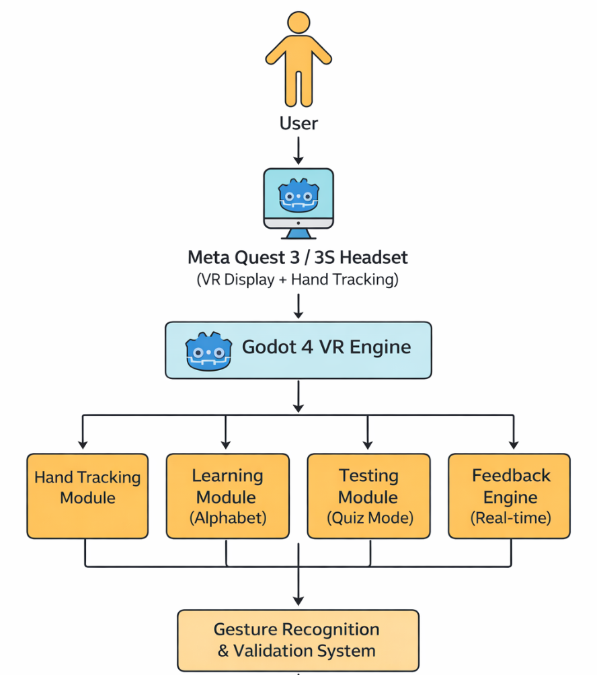
Figure 1: System Architecture Diagram for Sign & Spell VR

Project Aims and Objectives

Overall aim and some milestones along the way to achieve the aim
- 5-9 objectives

Project Scope

Project scope, what the project isn’t about

Thesis Roadmap

One sentence summary of the following chapters

2. Literature Review

2.1. Introduction

In this chapter …

2.2. Alternative Existing Solutions

Software you’ve looked into

2.3. Technologies Researched

Programming languages, operating systems, etc.

2.4. Other Relevant Research

Domain specific research

2.5. Existing Final Year Projects

2.6. Conclusions

3. System Analysis

3.1 System Overview
Initial general description of system from a user perspective
Non-technical description

3.2 Requirements Gathering
Identify and consider key stakeholders
Describe how to collect requirements
Collect initial requirements

3.3 Requirements Analysis
Develop an initial systems model through analysis of requirements

3.4 Logical Architecture of System

3.X Other Section

3.X Initial System Specification

Document and identify the initial functional and non-functional requirements for system
Identify an appropriate architecture for the system

3.X Conclusions

4. System / Experiment Design

4.1 Introduction

4.2. Software Methodology

4.3 Project Planning

Describe the approach used for planning the project development.

4.3.1 Project Schedule

Description and Gantt Chart

4.5. Overview of System

Describe modules / Components / Experimental approach
Include a diagram, Physical Architecture (Infrastructure) diagram

4.5.1 Fulfilment of System Requirements

Describe how system design matches and delivers on the system requirements.
Logical architecture as a guide

4.X. Other Sections as needed

Include a diagram

4.X. Conclusions

5. System / Experiment Development

5.1. Introduction

5.2. Software Development

5.X. Other Sections as needed

5.X. Conclusions

6. Testing and Evaluation

6.1. Introduction

6.2. System Testing

6.3. System Evaluation

6.4. Evaluate Project Management

6.4.1 Evaluate Project Plan

6.4.1 Evaluate Project Execution

6.6. Conclusions

7. Conclusions and Future Work

7.1. Introduction

7.2. Future Work

7.3. Conclusions

References

[1] ASL Fingerspeller – SideQuest. Available: https://sidequestvr.com/app/1317/aslfingerspeller
[2] Silent Classroom VR – Meta. Available: https://www.meta.com/experiences/silentclassroom-aslvr/9249215595132131/
[3] ASL Champ! – ScienceDirect. Available:
https://www.sciencedirect.com/science/article/pii/S2949678024000096?
[4] DEF-ISL – App Store. Available: https://apps.apple.com/mt/app/def-isl/id6447841373
[5] D. Novaliendry et al., “Design of Sign Language Learning Media Based on Virtual Reality,”
Int. J. Online Biomedical Engineering (iJOE), vol. 19, no. 16, pp. 111–126, 2023.
https://www.researchgate.net/publication/375642351_Design_of_Sign_Language_Learning
_Media_Based_on_Virtual_Reality
[6] VR Sign Language Learning with Hand Tracking [Video]. YouTube, 2023. Available:
https://youtu.be/HeFut3Htrcw
[7] “Getting Started with Godot: The Open-Source Game Engine,” Meta.com, 2022.
https://developers.meta.com/horizon/blog/getting-started-with-the-open-source-game-engine-godot/
[8] “XR,” Godot Engine documentation, 2025. https://docs.godotengine.org/en/4.4/tutorials/xr/index.html
[9] Danielle Bragg, Naomi Caselli, Julie A. Hochgesang, Matt Huenerfauth, Leah Katz-Hernandez, Oscar Koller, Raja Kushalnagar, Christian Vogler, and Richard E. Ladner. 2021. The FATE Landscape of Sign Language AI Datasets: An Interdisciplinary Perspective. ACM Trans. Access. Comput. 14, 2, Article 7 (June 2021), 45 pages.
https://doi.org/10.1145/3436996
[10] Danielle Bragg, Oscar Koller, Mary Bellard, Larwan Berke, Patrick Boudreault, Annelies Braffort, Naomi Caselli, Matt Huenerfauth, Hernisa Kacorri, Tessa Verhoef, Christian Vogler, and Meredith Ringel Morris. 2019. Sign Language Recognition, Generation, and Translation: An Interdisciplinary Perspective. In Proceedings of the 21st International ACM SIGACCESS Conference on Computers and Accessibility (ASSETS '19). Association for Computing Machinery, New York, NY, USA, 16–31. https://doi.org/10.1145/3308561.3353774
[11] Sushant Kafle, Abraham Glasser, Sedeeq Al-khazraji, Larwan Berke, Matthew Seita, and Matt Huenerfauth. 2020. Artificial intelligence fairness in the context of accessibility research on intelligent systems for people who are deaf or hard of hearing. SIGACCESS Access. Comput., 125, Article 4 (October 2019), 1 pages. https://doi.org/10.1145/3386296.3386300
[12] “WFD AND WASLI STATEMENT ON USE OF SIGNING AVATARS Click here for International Sign Version.” Accessed: Nov. 06, 2025. [Online]. Available: https://wasli.org/wp-content/uploads/2023/07/WFD-and-WASLIStatement-on-Avatar-FINAL-14032018-Updated-14042018-1.pdf
[13] “Saving games,” Godot Engine documentation.
https://docs.godotengine.org/en/stable/tutorials/io/saving_games.html
[14] L. Jones, “Using Meta Quest Headsets in Education: 3 Powerful Ways Educators Can Get
Started,” Thinglink.com, Oct. 27, 2025. https://www.thinglink.com/blog/using-meta-quest-headsets-ineducation-3-powerful-ways-educators-can-get-started/
[15] Y. Ding and J. Hao, “The Application of Educational Games Based on Virtual Reality Technology in Teaching English in Universities,” Systems and Soft Computing, p. 200380, Aug. 2025, doi:
https://doi.org/10.1016/j.sasc.2025.200380
[16] Z. Zhang, “Innovative Application and User Experience of Virtual Reality Technology in Human-Computer Interaction,” Highlights in Science, Engineering and Technology, vol. 93, pp. 200–209, May 2024, doi: https://doi.org/10.54097/mx8yf812.
[17] M. Golubski, "VR Music Learner Final Project Report," BSc dissertation, School of Computer Science, Technological University Dublin, Mar. 2022.
[18] A. Botnari, “Sign Language Translator (SLT): Final Year Project,” BSc dissertation, School of Computing, Department of Science and Health, Technological University Dublin, 2017.

Appendix A: System Model and Analysis

Details of Requirements gathering and analysis method

Appendix B: Design

Details of design approach used
System elements, components, classes

Appendix C: Prompts Used with Gen AI

ChatGPT, CoPilot, Claude etc.

C.1 Prompts related to Report Writing

C.2 Prompts Related to Research

C.3 Prompts Related to Design

C.4 Prompts Related to Coding

C.5 Other Prompts Related to Proejct

Appendix D: Additional Code Samples

Provide additional code samples
Organised by Logical Architecture

Appendix E:

Other Appendix

